EXPT NO:2 | Implementation of data visualization techniques
DATE: 06.01.2026 | Implementation of data visualization techniques

PRE-LAB QUESTIONS (PROVIDE BRIEF ANSWERS TO THE FOLLOWING QUESTIONS)
- Why is exploratory data analysis critical before model building?
- Understand Data structures
- Detect Outliers
- Choose appropriate models
- Identify data quality issues

- How do distributions influence algorithm selection in ML?
Ans: Understanding the distribution (e.g., normal vs. skewed) helps in "choosing appropriate models". For instance, certain algorithms assume normal distribution, and using them on skewed data without transformation can lead to poor predictions.

- What insights can outliers provide in business data?
Ans: Outliers act as "warnings". In business, they can represent "Valid Signals" or "Noise/Errors".

- Why are visual summaries preferred over raw tables?
Ans: Visual summaries can "communicate risk instantly" and "override managerial bias". Raw tables often hide critical patterns, as seen in the Challenger disaster where engineers failed to visualize the zero-failure cases.

- How does visualization improve business intelligence?
Ans: It "bridges the gap between engineers and executives". By making abstract data visible, it allows decision-makers to see "risk boundaries" and "trends" that justify actions, such as postponing a risky launch.
IN-LAB EXERCISE:
OBJECTIVE:
To explore data distribution and variability using advanced visualization techniques.

SCENARIO:
A startup analyzes e-commerce transaction data to understand customer spending behavior and detect abnormal purchase patterns.

IN-LAB TASKS (Using R Language)
- Plot histogram of transaction amounts
- Use boxplot to detect outliers
- Create heatmap of monthly sales intensity

Code:
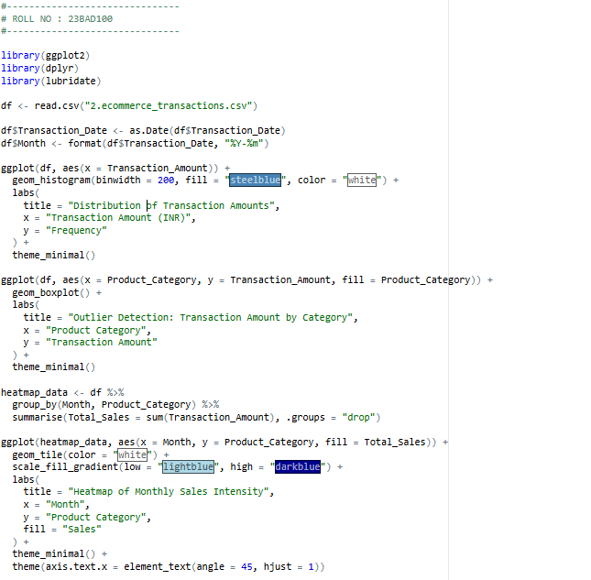

Output:

Histogram plot
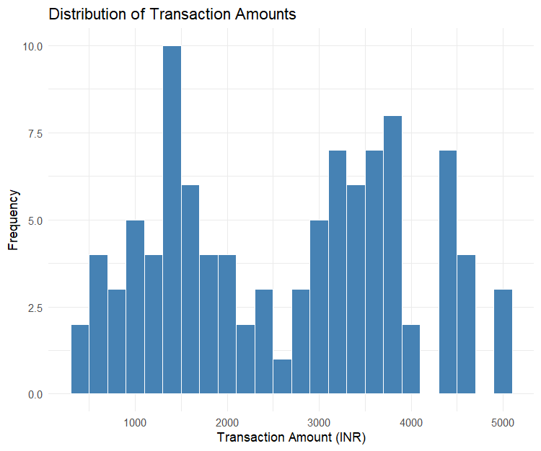

Box plot
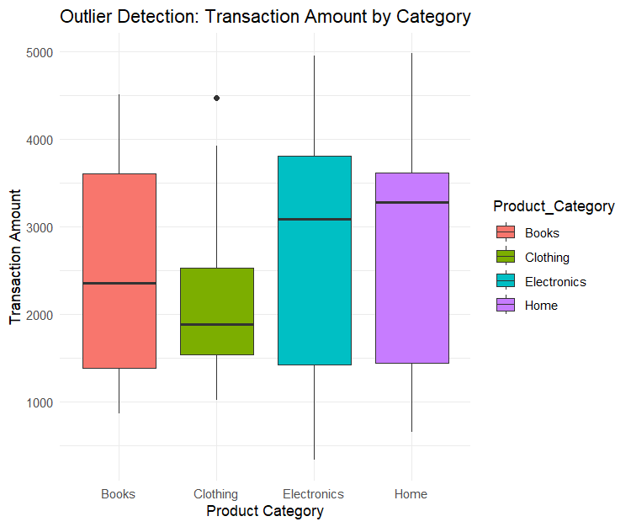
Heatmap:
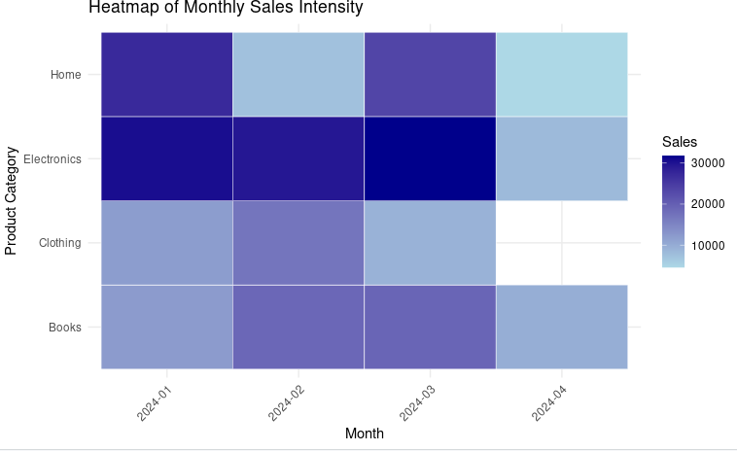

POST-LAB QUESTIONS (PROVIDE BRIEF ANSWERS TO THE FOLLOWING QUESTIONS)
- What does right-skewed distribution indicate about customer behaviour?
Ans: It indicates that the majority of customers make small-value purchases, while a very small number of customers (the "tail") spend significantly high amounts. In e-commerce, this is common and helps identify "high value" customers vs. mass-market buyers.

- How can detected outliers impact business decisions?
Ans: Outliers can skew averages, leading to unrealistic targets if treated as normal (as mentioned in the "Mean w/o Context" slide). However, detecting them allows businesses to either filter out fraud (if the outlier is an error) or create VIP programs (if the outlier is a high-spending customer).

- Which visualization best supports anomaly detection?
Ans: The Box Plot (or Box-and-Whisker plot) is best for this. It explicitly marks data points that fall outside the "whiskers" (interquartile range) as individual dots, making outliers immediately visible.

- How does EDA improve AI model accuracy?
Ans: EDA identifies "data quality issues" and "outliers" that could confuse a model. AI sometimes fail in distinguishing between “Noise” and “Valid Signal”.

- How can visualization guide feature engineering?
Ans: Visualization helps discover "relationships" and "correlations" between variables. For instance, if a heatmap shows that Electronics sell mostly in December, you might create a new feature called "Holiday_Season" to help the model predict sales better.

ASSESSMENT
Description | Max Marks | Marks Awarded
Pre Lab Exercise | 5
In Lab Exercise | 10
Post Lab Exercise | 5
Viva | 10
Total | 30
Faculty Signature

